**Energy Saving Use-Cases Operation**

**1. Energy saving with cell utilization:**

By monitoring the Base Station (BS) utilization or traffic load over a 24-hour period, the graph illustrates the fluctuations in traffic throughout the day, highlighting periods of both high and low utilization.

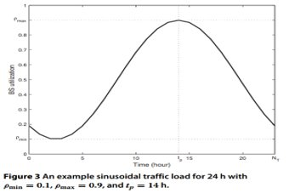

This enables us to conserve network energy during periods of low cell utilization. Let us demonstrate how to simulate this scenario using our RIC TaaP tester:

1. Ensure that FlexRIC is running in the background.

2. Set the simulation parameters as follows, then press Start new :

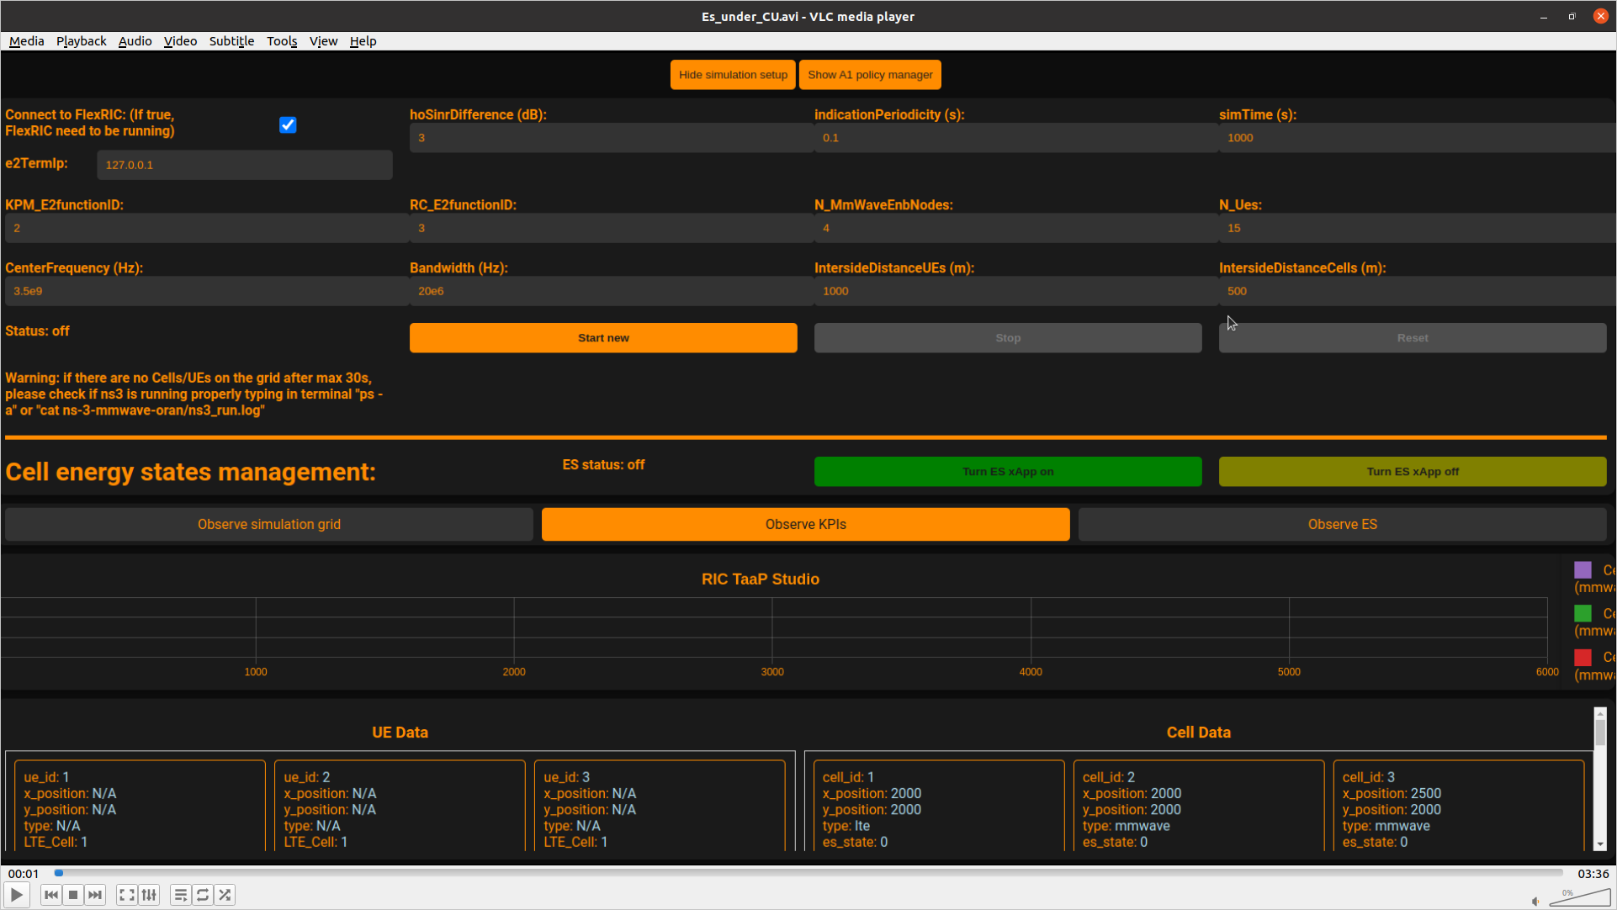

**N_UEs = 15**

**IntersideDistanceCells = 500**

**IntersideDistanceUEs = 1000**

After the nodes and UEs are running and appear in the simulator, we will observe the following:

**Cell 2 is connected to 2 UEs**

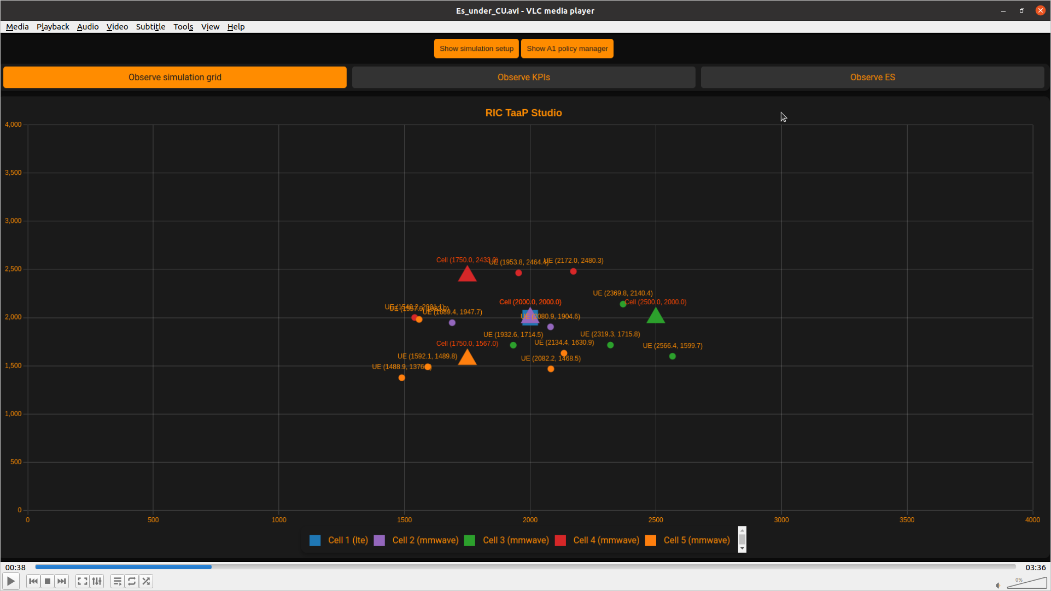

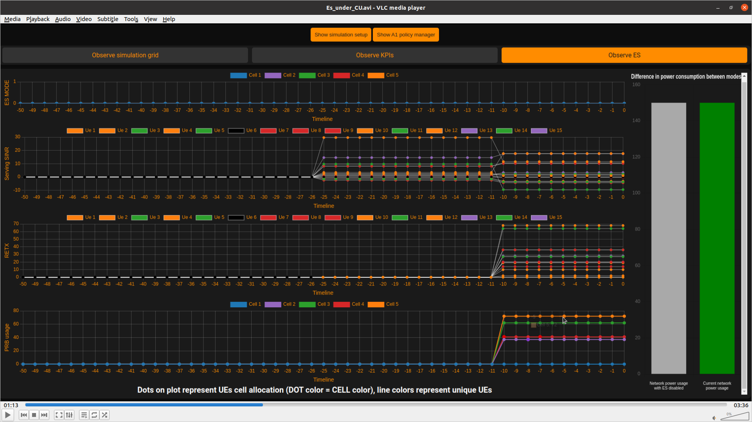

**UE 13 and UE 15 are attached to cell 2**

**Cell 2 has the lowest PRBusage**

3. Run the xapp_energy_saving_with_CU by executing the following command in the terminal:

./flexric/build/example/xapp/c/ctrl/xapp_energy_saving_with_CU

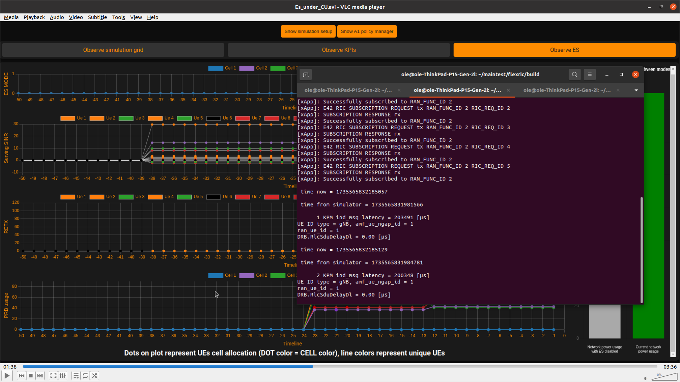

**What is the action of the xApp?**

The xApp sends a RIC control message to Cell 2, instructing it to move the two UEs attached to it to the nearest cells and then power it down. Let us demonstrate this action in the following:

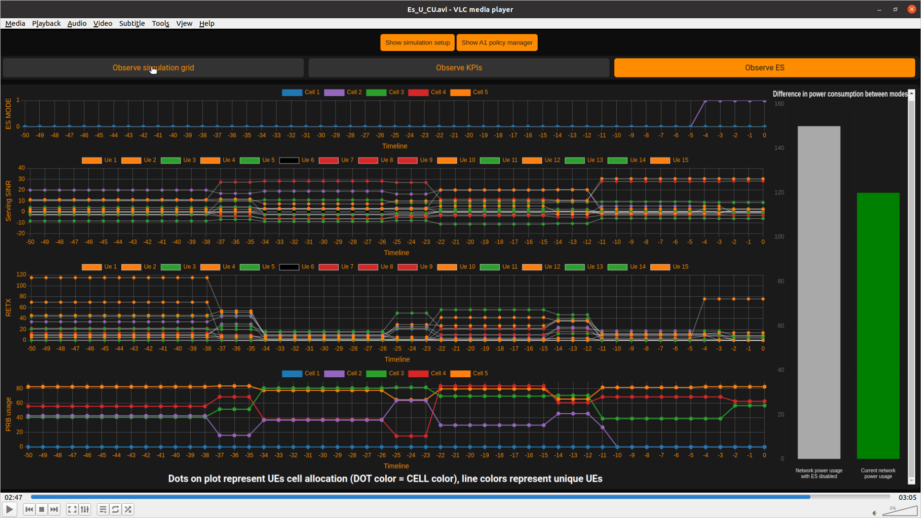

**UE 15 is attached to cell 5**

**Energy state flag for cell 2 =1**

**This means Cell 2 is turned off**

**UE 13 is attached to cell 3**

**After handover the PRBusage of cell 2 is equal to zero**

**Current network power after Es operation**

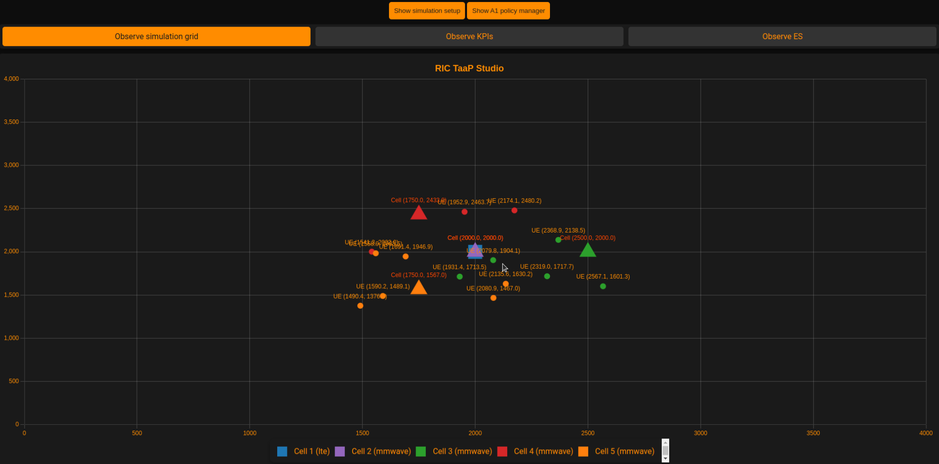

**2. Energy saving with load balancing:**

This approach focuses on optimizing network performance while minimizing energy consumption through intelligent resource allocation and dynamic load redistribution.

Let us demonstrate how to simulate this scenario using our RIC TaaP tester:

1. Ensure that FlexRIC is running in the background.

2. Set the simulation parameters as follows and press Start new :

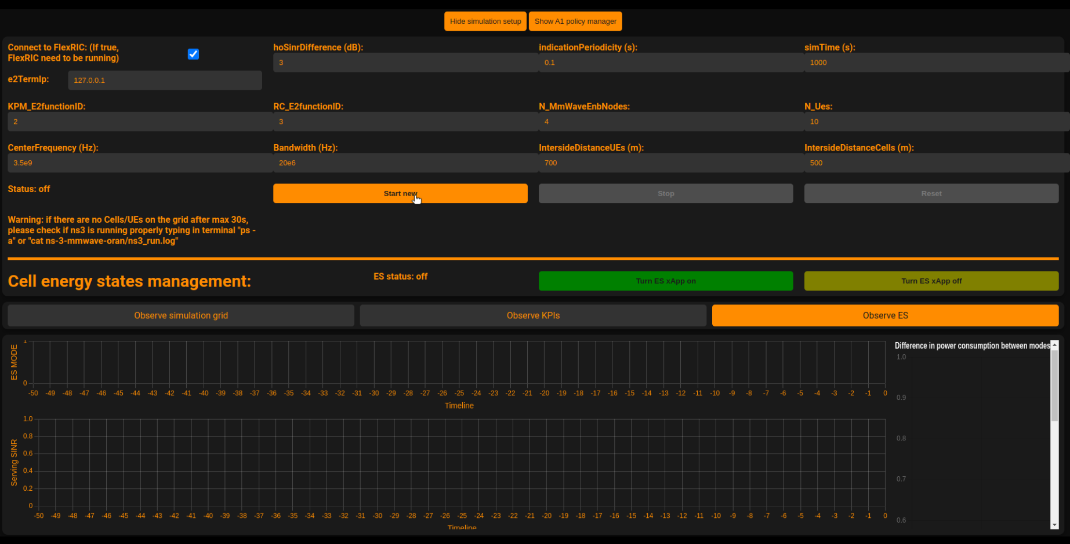

**N_UEs = 10**

**IntersideDistanceCells = 500**

**IntersideDistanceUEs = 700**

After the nodes and UEs are running and appear in the simulator, we will observe the following:

**Cell 2 is connected to 4 UEs**

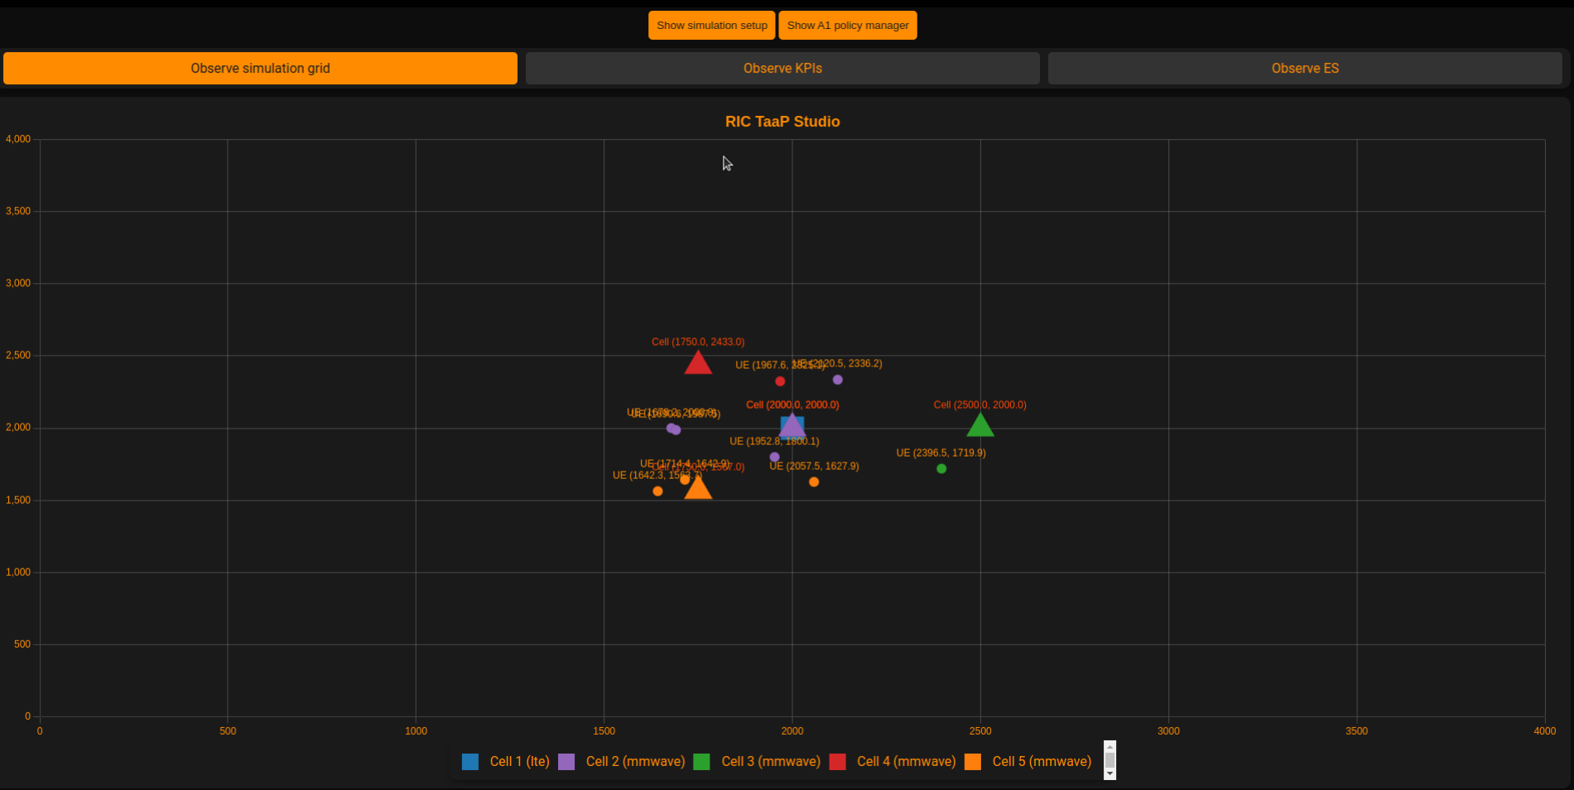

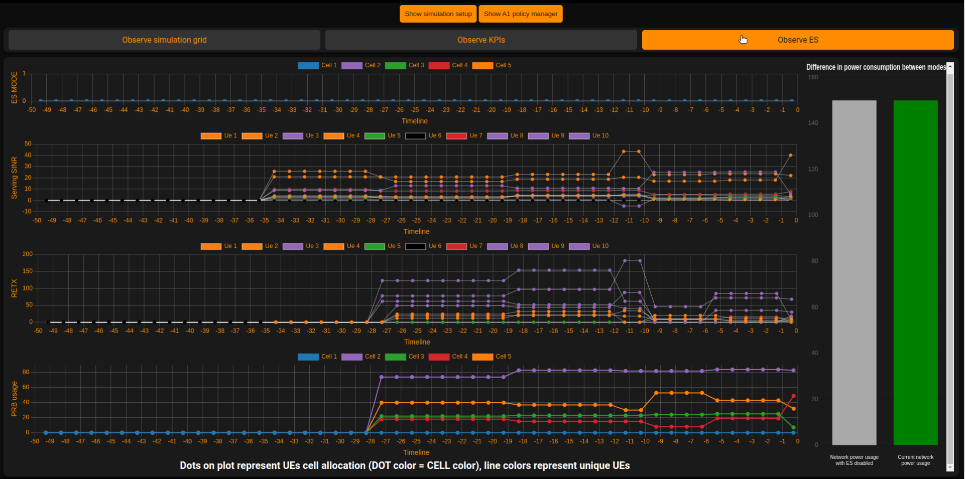

**UE’s 3,8,9 and 10 are attached to cell 2**

**Cell 2 has the biggest PRBusage**

3. Run the xapp_energy_saving_with_LB by executing the following command in the terminal:

./flexric/build/example/xapp/c/ctrl/xapp_energy_saving_with_LB

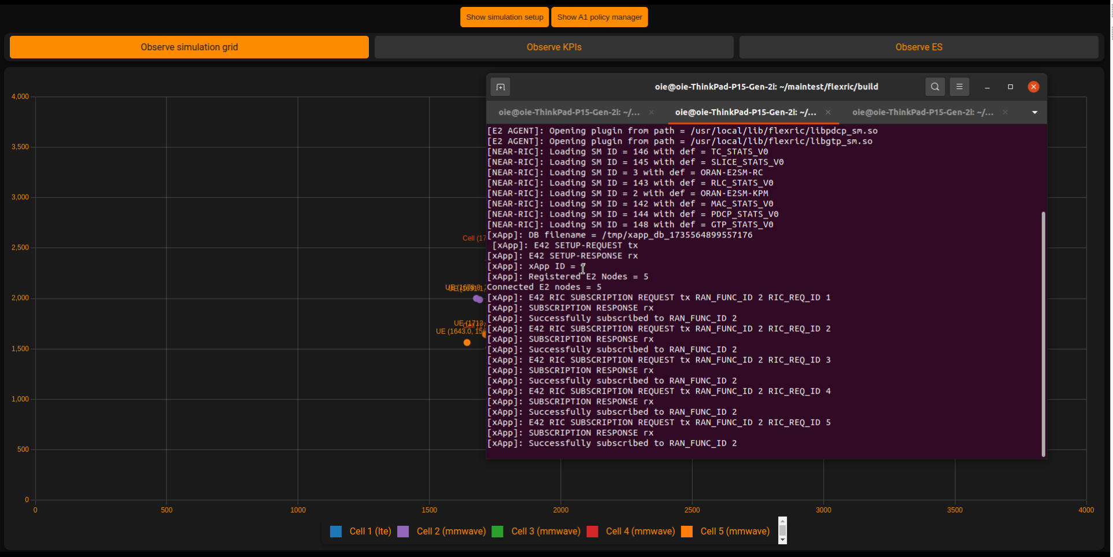

**What is the action of the xApp?**

The xApp sends a RIC control message to Cell 2, instructing it to move the UEs attached to it to the nearest cells and then power it down. Let us demonstrate this action in the following :

**UE 10 is attached to cell 5**

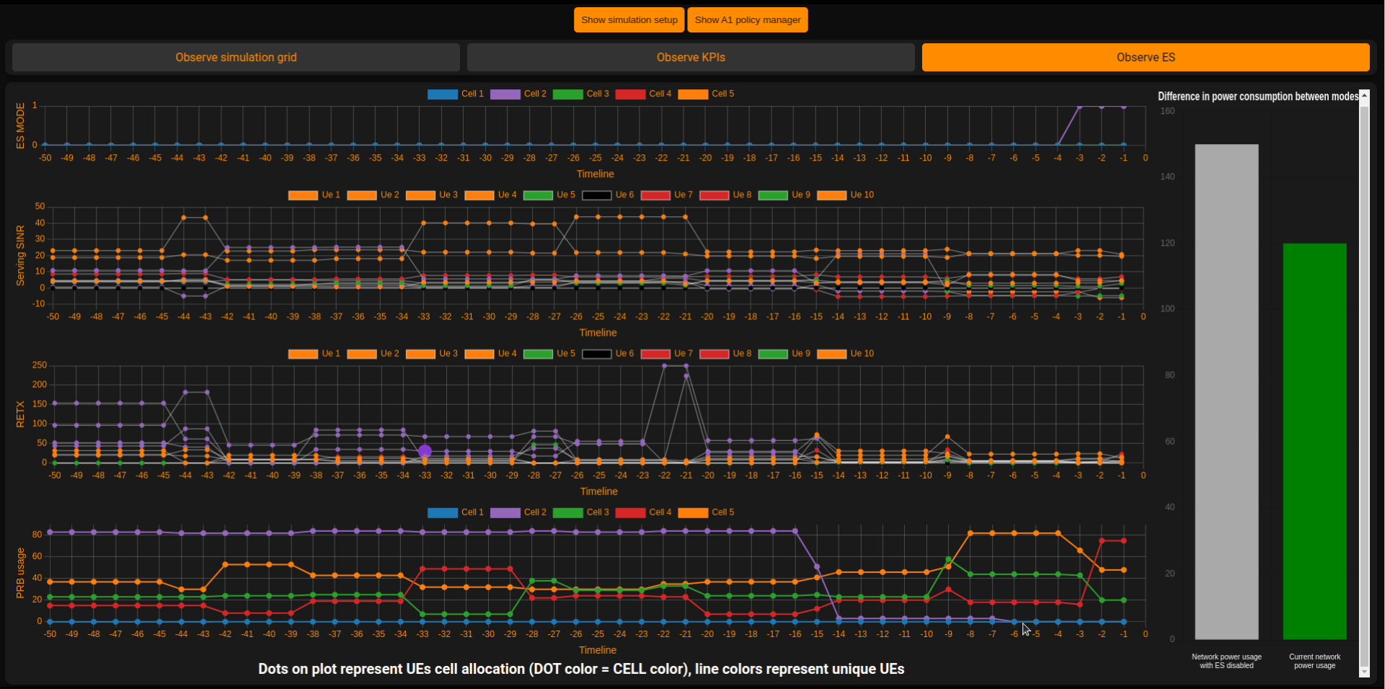

**Energy state flag for cell 2 =1**

**This means Cell 2 is turned off**

**UE 9 is attached to cell 3**

**UE 8 is attached to cell 4**

**UE 3 is attached to cell 5**

**After handover the PRBusage of cell 2 is equal to zero**

**Current network power after Energy saving operation**

